Date | 03 October 2026
Team ID | SWTID-2026-7735
Project Name | Auto Ticket Classification using Flow Designer
Maximum Marks | 2 Marks

Ideation Phase
Define the Problem Statements
Customer Problem Statement Template:
Create a problem statement to understand your customer's point of view. The Customer Problem Statement template helps you focus on what matters to create experiences people will love.
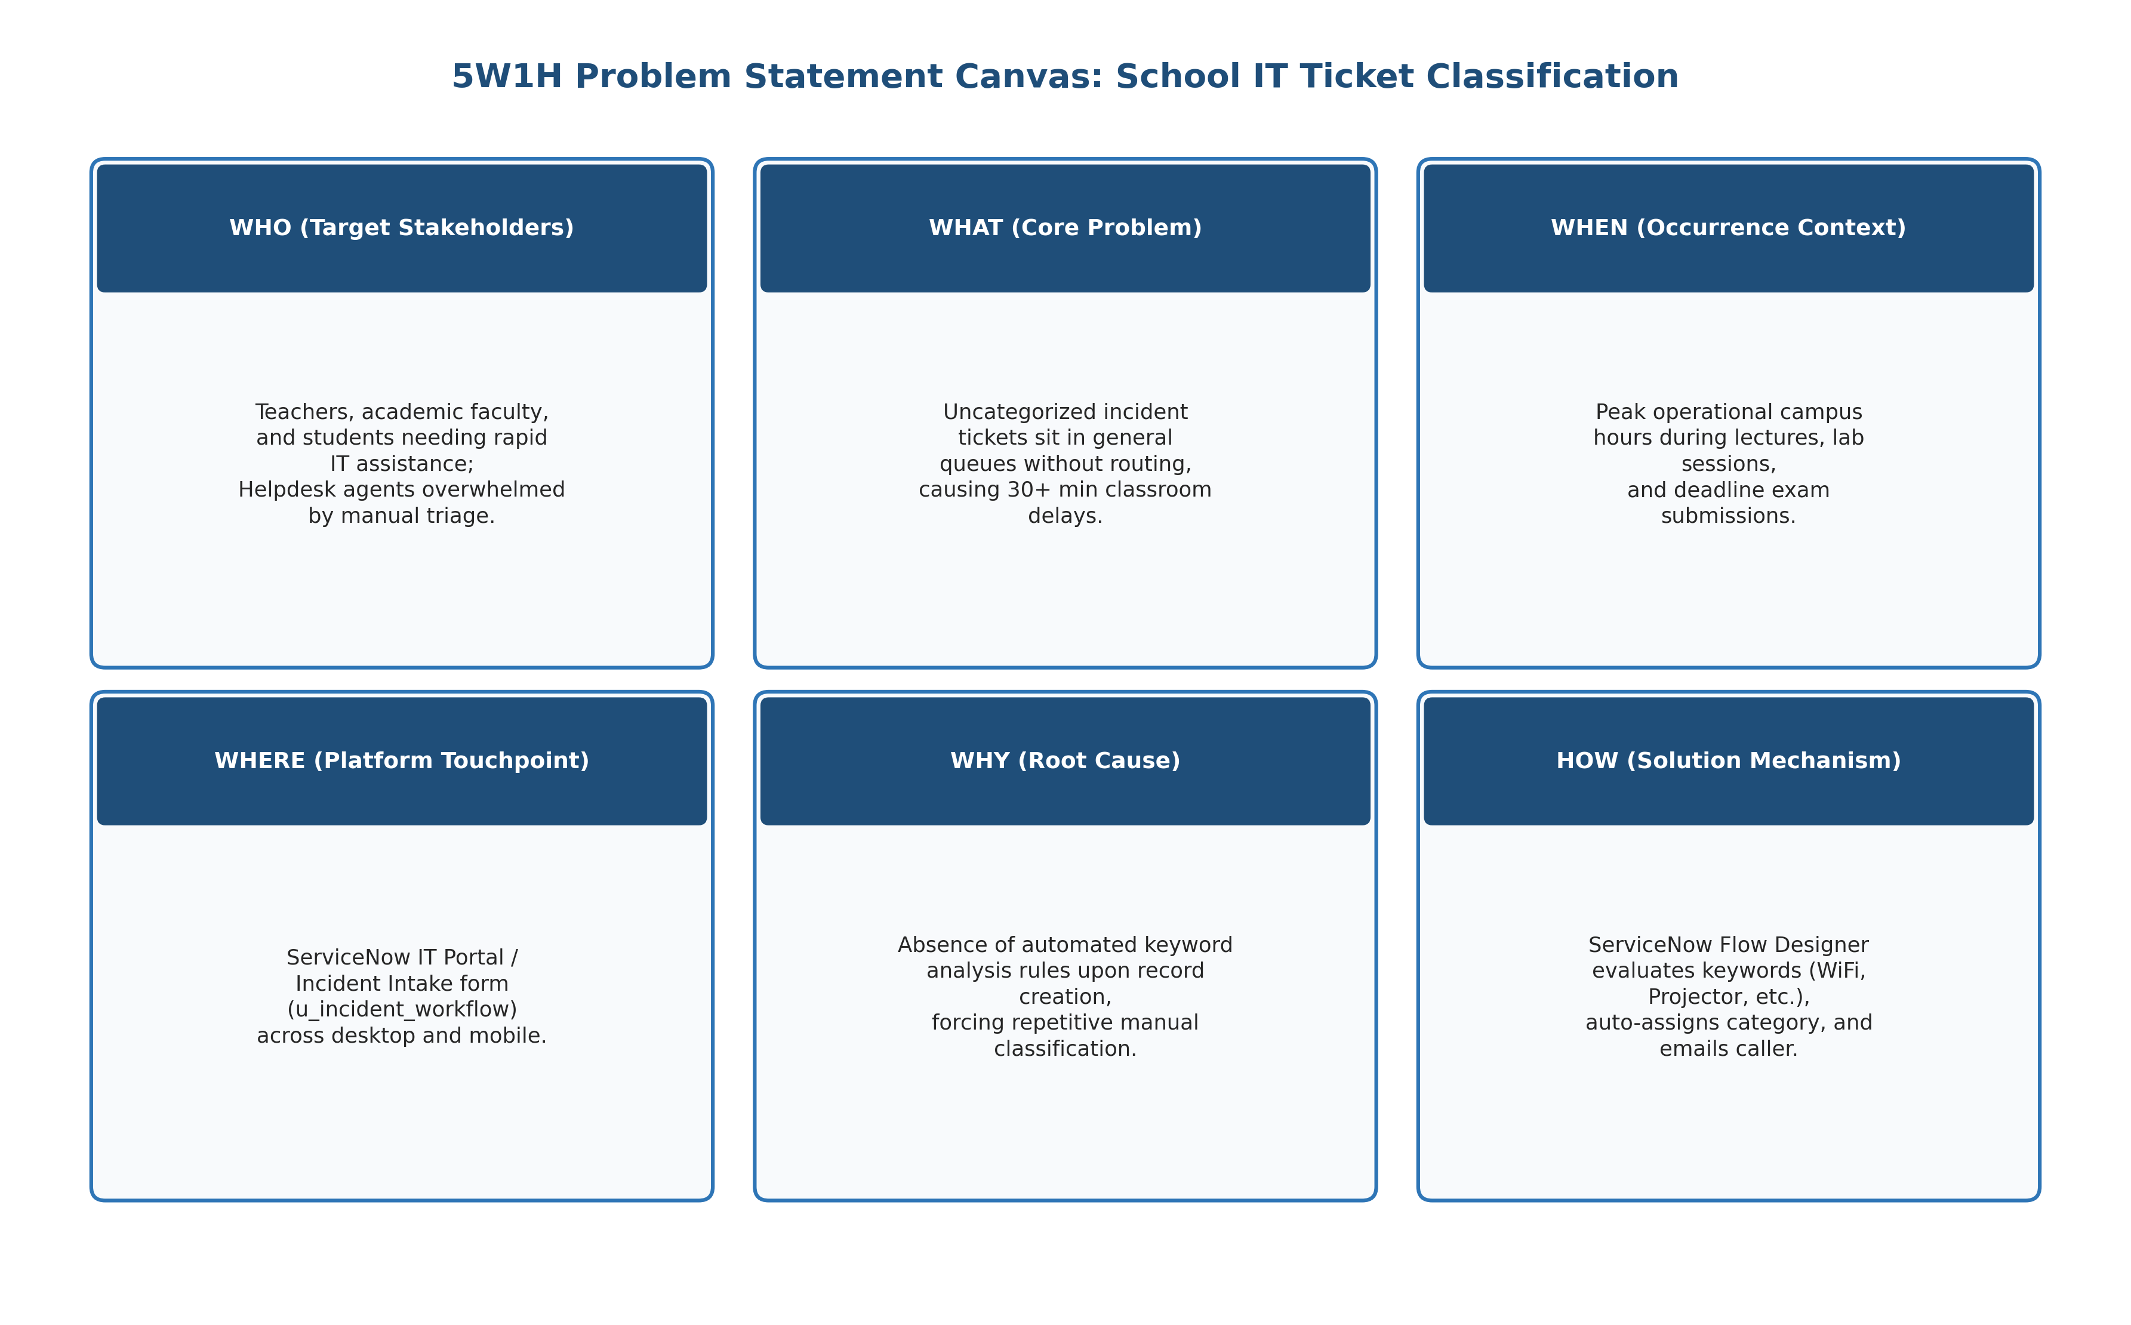
Figure 1.3: Customer Problem Statement 5W1H Framework Canvas
Example & Problem Statements Definition:
Problem Statement (PS) | I am (Customer) | I'm trying to | But | Because | Which makes me feel
PS-1 | Teacher in Classroom | Start presentation with classroom projector or Wi-Fi | The projector fails to connect or library Wi-Fi drops | Ticket sits in general queue waiting for manual review | Stressed and helpless while valuable lecture time is wasted
PS-2 | Student in Lab | Reset password to access online portal for exam submission | I cannot classify complex IT categories correctly | The system lacks automated keyword routing & email receipts | Anxious and worried about missing assignment deadlines
PS-3 | IT Helpdesk Admin | Quickly resolve critical campus hardware and network issues | I spend 30% of shift manually sorting and classifying tickets | System lacks automated intake logic and dependent choices | Overwhelmed by repetitive administrative triage overhead

